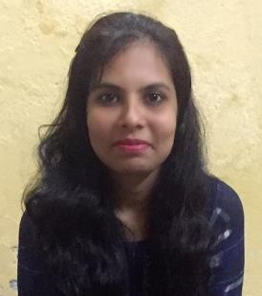
BIO DATA

Name:Dipika Abhijeet Ghodke (Bagul)
DOB: 29-Jan-1991 Gender: Female
Marital Status: Married Religion: Hindu
Email Id: deepikabagul291@gmail.com Mobile No: 9404266995 Language Known: English, Marathi, Hindi

Educational Details

Education | Institute Name | Year of passing | Marks
S.S.C. | H.R.Patel High School, Shirpur | March 2006 | 72.00%
H.S.C. | H.R.Patel Junior College, Shirpur | Feb 2008 | 60.50%
B.C.A (T.Y) | R.C.Patel IMRD College, Shirpur | May 2014 | Appeared

Work Experience

Fresher

Hobbies & Interest

Computers, Reading, Travelling.

Address

C/O. P.D.Patil, Plot No.17, Gut No.92, Peshwe Nagar, Behind Ration Shop, Satara Parisar, Aurangabad – 431010

Declaration: I hereby declare that all the information provided here is true to the best of my knowledge.

Place: Aurangabad
Date: Signature

