RESUME
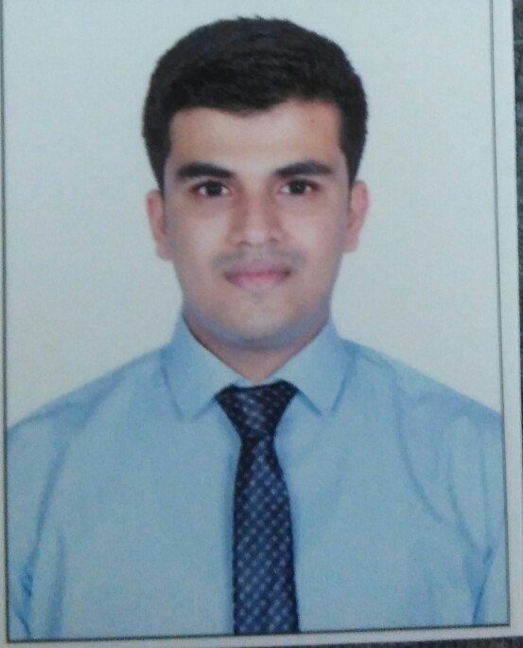

Mr. Gaurish Vasant Prabhu
Contact No. 8657458841
E-mail address : gaurishvp@gmail.com

CAREER OBJECTIVE

To learn, improve and excel in my profession & corporate world by obtaining a

rewarding position by contributing my entire knowledge and experience in my field.

EDUCATIONAL QUALIFICATION

Exam | School/College | Board/University | Year of passing | Percentage of marks
S.S.C | St Xavier’s High School,Goregaon(E). | Maharashtra | 2011 | 65%
H.S.C | Patkar College, Goregoan (E) | Maharashtra | 2012 | 55%
B.S.C in Hospitality Studies and Catering Science | Atithi School Of Hospitality & Management | YCMOU | 2017 | 62%
Msc in Hospitality Studies and Tourism Management | Madhurai Kamraj University | Madhurai Kamraj University | 2019 | 72%

WORK EXPERIENCE:
THE WESTIN MUMBAI GARDEN CITY, MUMBAI (2017-2018)
Designation: Front office Associate
Job Role: Taking care of guest registration, handling guest complaint, managing restaurant booking, air ticket, handling guest luggage etc.

Kesari Tours Pvt Ltd, Mumbai (2019- 2020)
Designation: Guest Relation cum Tour Leader
Job Role: Taking care of guest complaint and solving queries. Taking care of guest while they are on tour.

Patkar Varde College, Mumbai (2021)
Designation: Public Relation Officer and Lecturer for Masters in Travel and Tourism Course.
Job Role: Managing reputation of organization by various sources and taking lectures for masters students.

INTERNSHIP:
Hotel Name:-Sahara Star, Mumbai (4th June to 3rd Sep 2015)
Departments:-Food and Beverage Service. (1 month)
Front Office (2 Months)
CURLICULAM ACTIVITIES:
- Participated in Young Turks Food Festival.
- Participated in Chocolate Making Competition.
- Participated in College Theme Lunch.
- Participated in various college events like Christmas, Eid, Chetichand, Diwali throughout my academics years.
- Invited for Board of Studies Meeting for Masters in Travel and Tourism course
ACHIVEMENTS:
- Awarded as a Star Performer at Kesari Tours Pvt Ltd.
- Awarded as a Kesrian Of The Month at Kesari Tours Pvt Ltd.
- Awarded by Westin Mumbai Garden City for good work.
- Awarded by JW Marriott Juhu, for highest number of waiting hours (225 hrs) in 2014-2015.
- Winner OF Culinary Olympic (YTFF) 2016
- Winner in Chocolate Making Competition 2016-2017

STRENGTHS :
- Innovative
- Optimistic
- Determined
- Leadership skill
- Self-Motivated

HOBBIES AND INTERESTS :

- Photography
- Playing Badminton , Cricket
- Surfing on Internet

PERSONAL DETAILS

Date of Birth : 09/03/1994

Sex : Male

Marital Status : Single

Nationality : Indian.
Languages Known: English, Hindi and Marathi, French (Learning).

DECLARATION :

The information given above is true to the best of my knowledge and I will be responsible for any flaws in it.

DATE:

PLACE: Mumbai.

GAURISH VASANT PRABHU

