Smita Holidays Website Update to Be Done

a)Front End – Home Page
1. Heading – Replace Though to Through
2. Category Box Showcased are wrong – Only Active Category need to be Showcased and sequence Management must be there.
3. Similarly for Search Box the itinerary Suggestion must be of Only Active Category.
*4. Safety Text and Image Attached with the file.
5. SHP Icon Change for 1: Plan 2: Invest; How it Works needs more space between words. And Add ? to it >>> How It Works ?
6. Instead of Affiliated Partners change to - What Set’s Us Apart
7. At Partner Logos Share us Logo Size so we can add accordingly (At Present no Logo is Shown)
*8. For Footer Section Check This Image: 4 Column Sequence as Shown
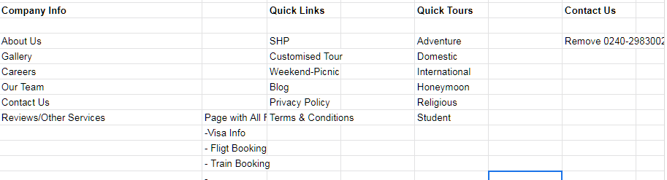
b) Front End – SHP Page
1. Search Box (Suggestion Need Only for SHP Category)- After Search: On Page only should display Tour Listing.
*2. SHP Points – Spelling Correction: Safety(5th line) & Last Line Update
“One instalment is free from Smita Holidays or Weekend Tour”
3. On Hover/Beside Heart Logo-Text (Add to wishlist)
4. Above Tour Listing Add 4 Boxes with Text as Shown
Travel to Destination
Pay 12th SHP
Start SHP
Check Monthly Instalment
Choose Destination

5. Request for Customize - Redirect to Customized Tour with same tour name pre define
6. SHP Video Link - https://youtu.be/rq-zD5x95Ec
7. Tour Details Page Replace “About this tour” to – “Highlights ”
8. Pricing Part: Starting From ₹ 1200/- Per Person Per Month. With T.C. Apply Icon
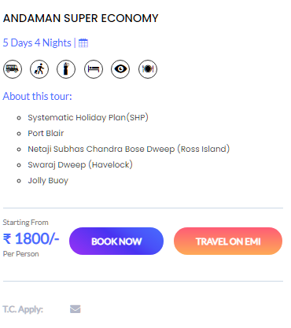
Per Person Per Month
T.C. Apply:

9. Tour Details DAYS Tab Access Required –
10. Replace Travel on EMI with Travel with SHP
11. Email Option to Tab After Days
11. After an Itinerary Add Book Now (Button)
c) Front End (About Us Page)
1. Change Spelling Winters to – Witness (2nd Column – 2nd line)
d) Front End (All Tour Category)
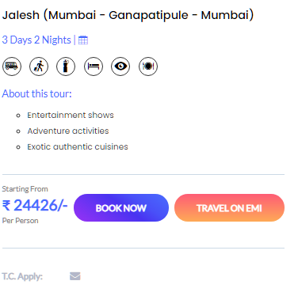
Travel On SHP
1. Per Person
T.C. Apply:
2. Tour Details Page DAYS Tab Access Required
3. After an Itinerary Add Book Now (Button)

e) Front End (Careers)
Replace Text : Any kind of travel information don't hesitate to contact with us for immediate customer support. We are love to hear from you.
To: Join our Great Team of Talented Individuals in a Dynamic and high-growth Industry.
f)Backend
1) Access Required
> Category Add/ Delete with Sequence Arrangement
> Sign in Details and Access
> Top Destinations & Top Deals Setting up Access
> Smita Points Set/Add/ Delete/Edit Access
> Sequence Arrangement of Tours Access

g) Backend (Tour Adding Issue)
> Old Tour Data Country set Wrong (Proper Link to Old Data)
> When we try to update any Tour the Default tour type is SHP in Backend.
>

